Eight Discipline Report (8D Report)
To: | 8D report No.: 2023/11/01
From:：Chicony Power Technology | RMA claim No.: N/A
CC： | Chicony Power P/N: W065RP71P-CT01
CC： | Customer P/N: Chicony Power Technology
Submit date: 2023/11/06 | Product description: 65W wall mount adapter
Receive date:
Subject：AC小線插板後, 板下高度超規
D1.) 問題解決成員:Use Team Approach
主持者 (Team Leader)：Ivan_Lu
內部成員 (Internal Team Members):
ME : Ivan_Lu, Alan_Cheng; 工廠同仁
外部成員 (External Team Member):
Vendor : 瑞德
D2.)問題說明:Problem Description:
(Note: Use who, what, when, where, why, how, how many to specify the Customer’s problem.)
工廠組裝反饋AC小線插板後, 超過板下高度限制, 如下圖所示:
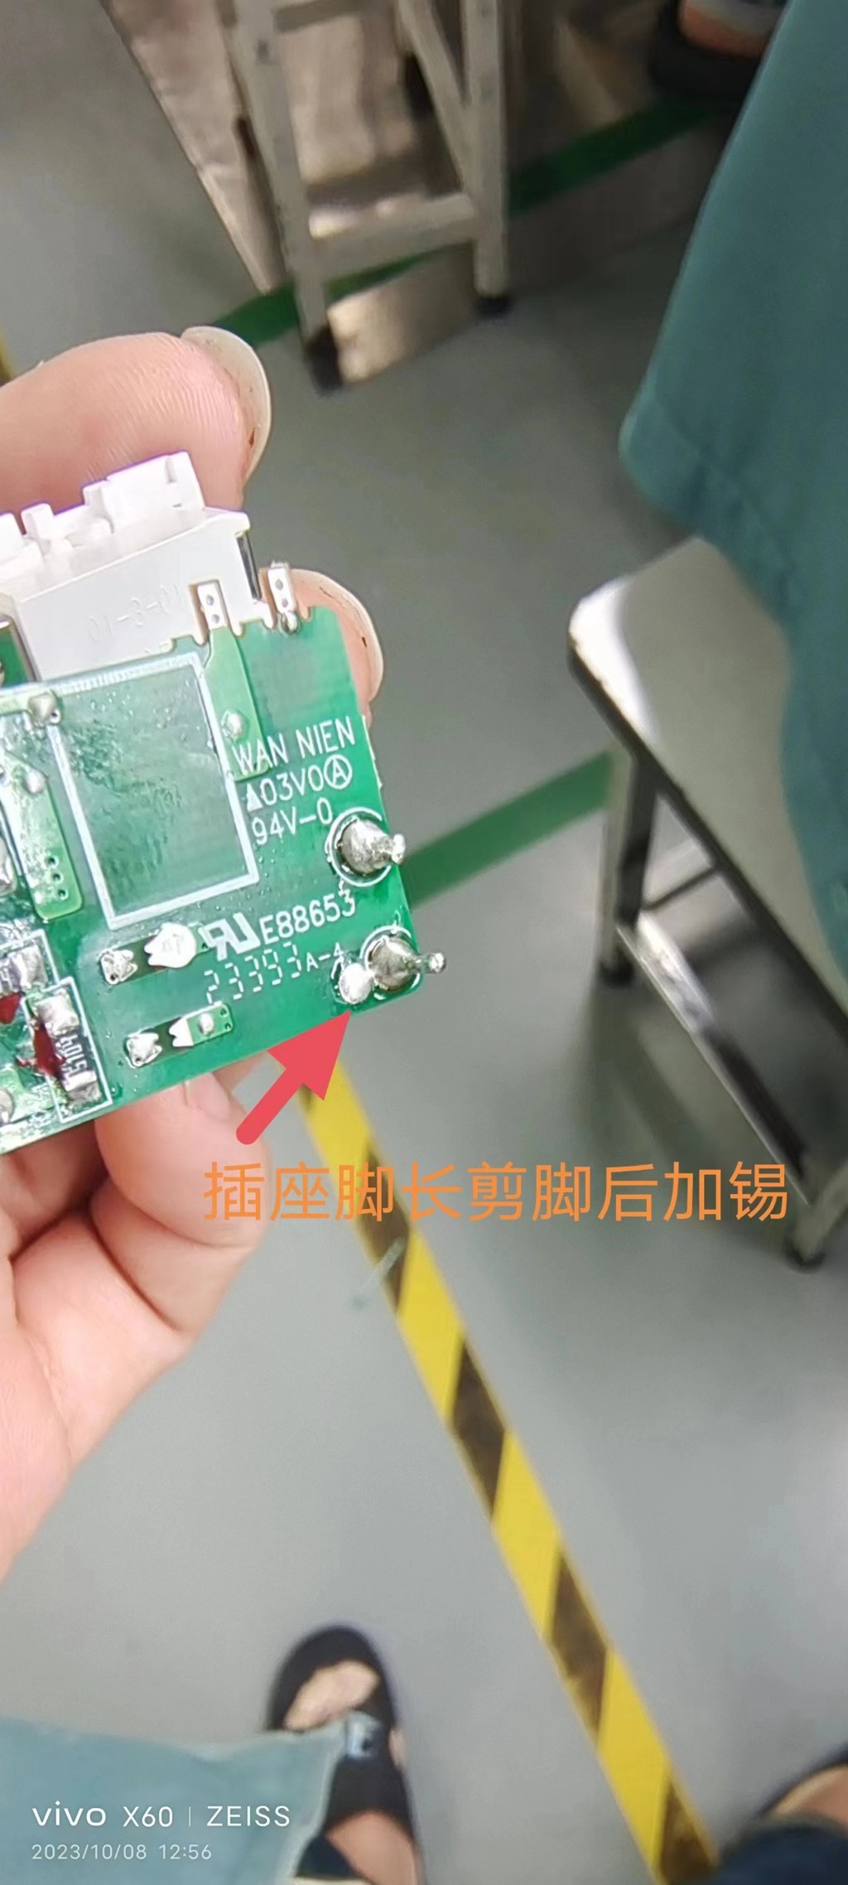
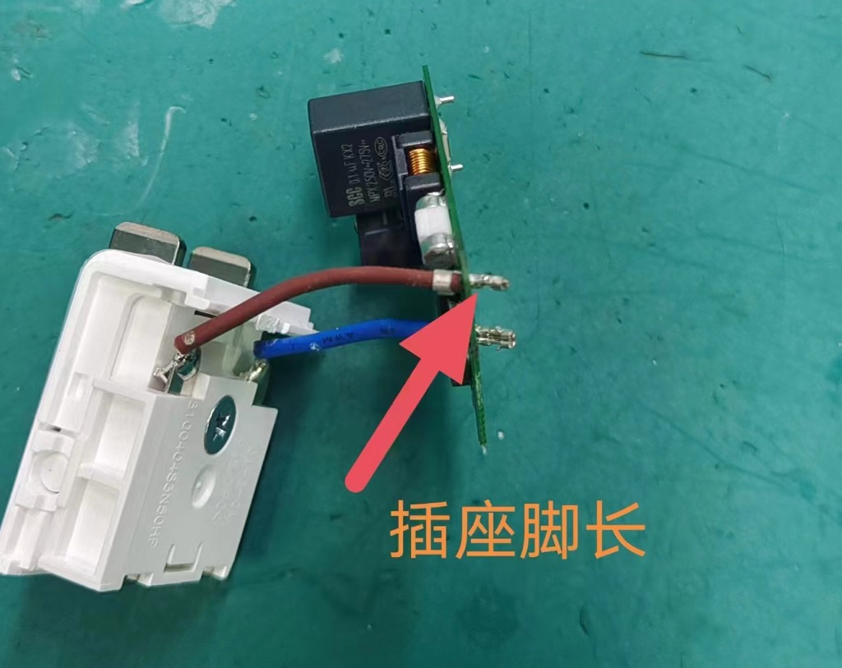

D3.)內部或客戶的暫時解決辦法及實施日期:Implement and Verify Containment Action:
(Note: Internal / external containment action effectiveness and date.)
焊接后, 剪脚再加锡
D4.)不良原因確認: Define and Verify Root Causes:
(Note: Identify and verify all suspect causes, which needs explain why the problem occurred.)
- 端子外觀:
  - 從下圖可觀察到端子小翅膀有變形的問題
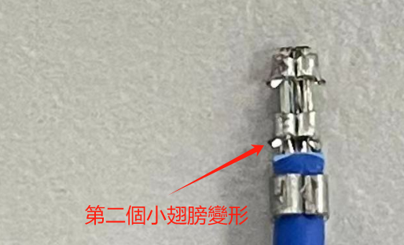
- 端子尺寸量測:
  - 第二個小翅膀變形後尺寸約1.55mm, 小板孔徑1.6mm, 小線插板後沒有限位點, 導致板下高度超規。
D5.)改善措施:Corrective Action Verification:
(Note: Be make sure the corrective actions is effective in process as well as able to fix the customer complaint problem)
短期對策:
焊接后剪脚, 再加锡
長期對策:
  - 新增圖面定義: 原圖面只有定義第一個小翅膀的尺寸, 圖面新增第二個小翅膀尺寸定義。
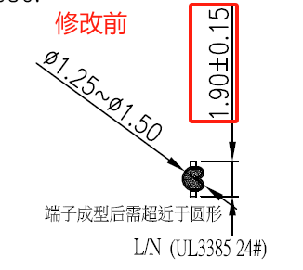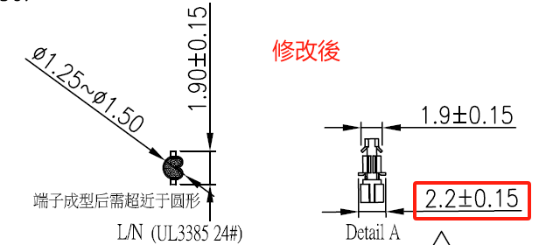

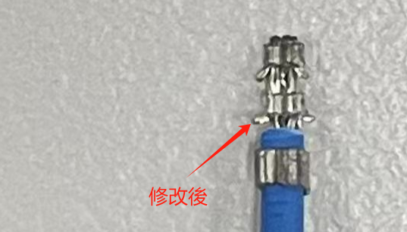

  - 更新CPT線材打端子規範:
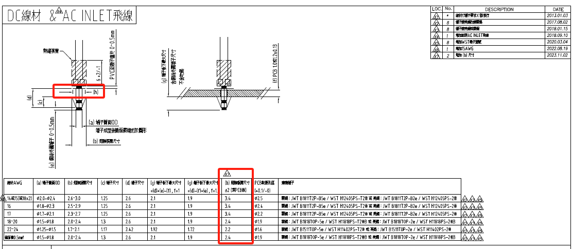
D6.)改善措施實施日期:Implement Permanent Corrective Actions:
(Note: Be provide the phase-in date or lot# of corrective actions implementation in process)
immediately
D7.)預防再發生措施:Prevent Recurrence:
(Note: Modified the management, operating systems, practices, and procedures to prevent recurrence for the problems as well as lessons learned cases.)
- 圖面上新增尺寸管控
- 廠商出貨量測尺寸管控
D8.)確認並感謝問題解決成員:Check and Congratulate the Team:
(Note: Recognize the collective efforts of the team.)
Thanks to you all！！！
ME: Ivan_Lu, Alan_Cheng; Vendor : 瑞德 ; 廠端同仁
感謝Hank_Lin幫忙更新線材打端子規範

